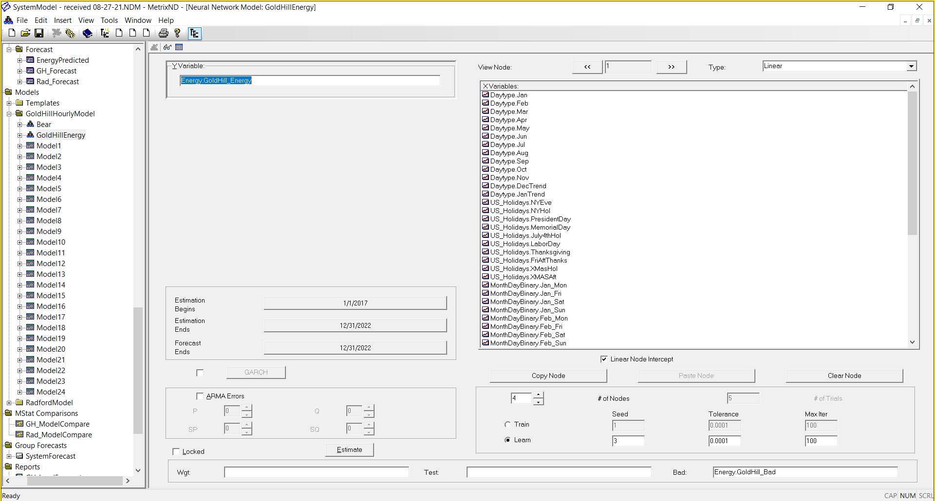

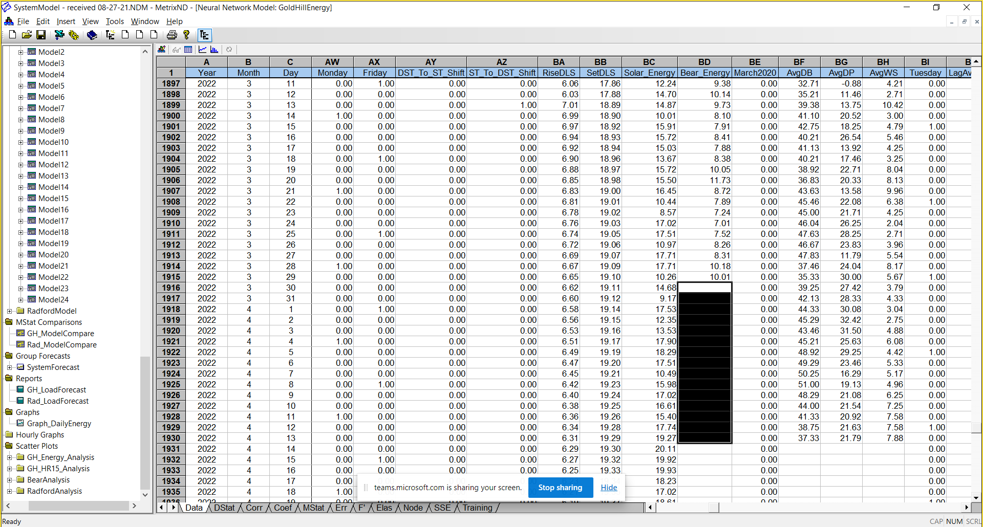

Take avg weekly shape for April 2022 with April 2021 and same for March weekday shape for Mar 2022 & Mar 2021

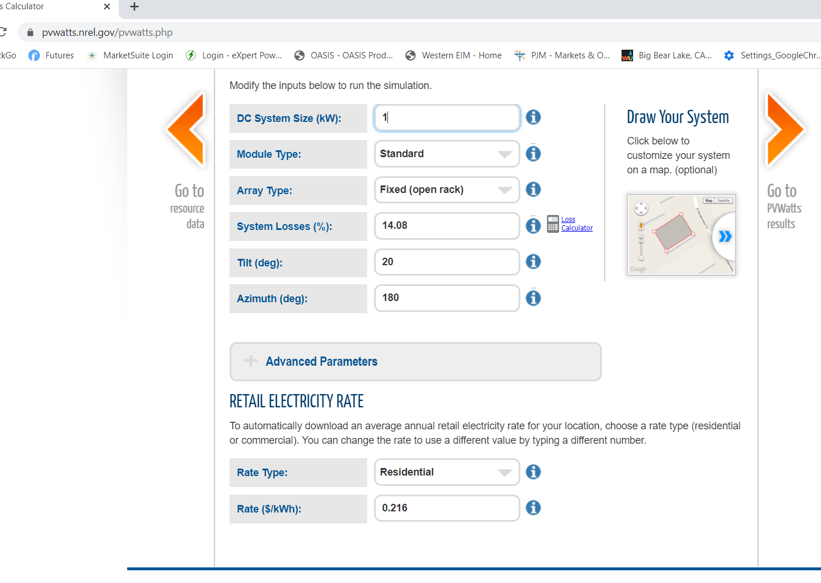

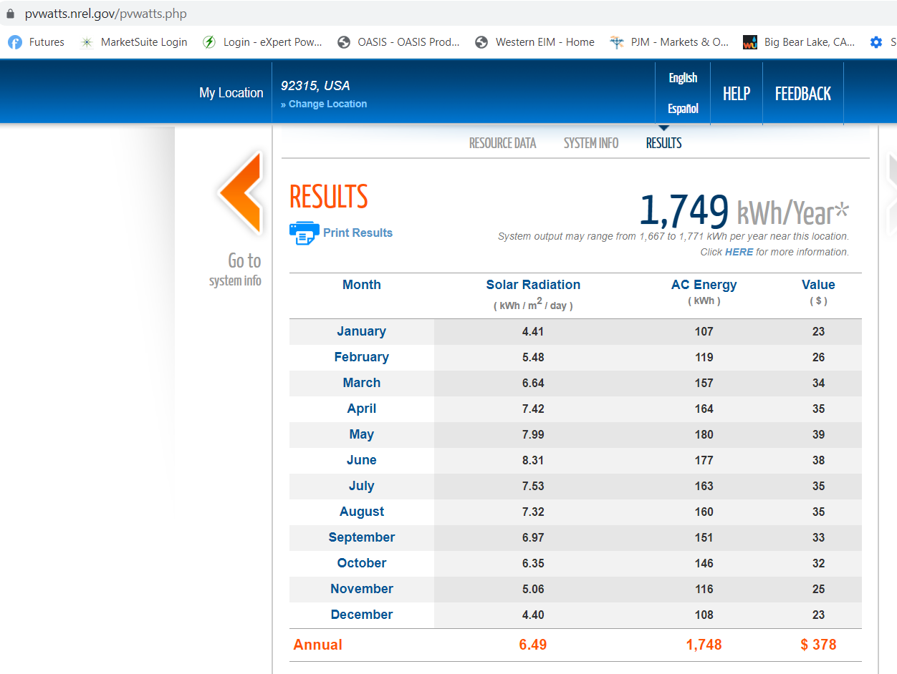

<https://pvwatts.nrel.gov/download-results.php?type=hourly>

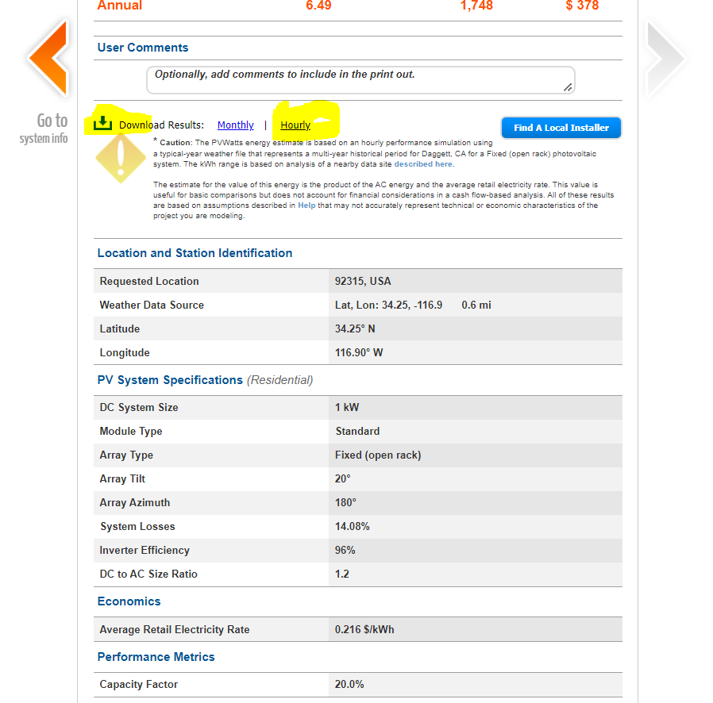

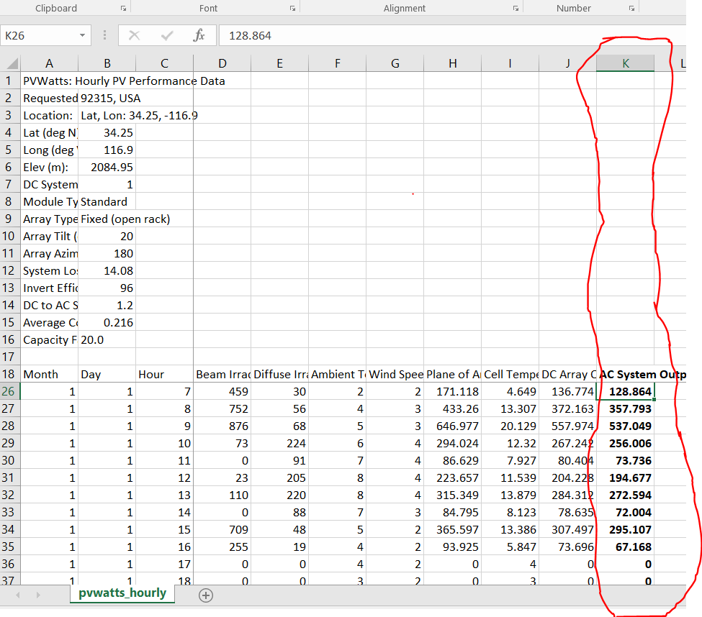we increased the solar profile installed capacity to 4,500 kW starting 4/1/22 seen below

